ARM926 Technical Reference Manual

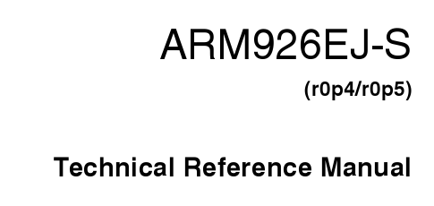

작성일 : 2006-11-21
작성자 : pooll

- ARM926EJS Block diagram
  - Memory Interface 위주
